- Add VM to Update Manager
- Modify VM update settings:
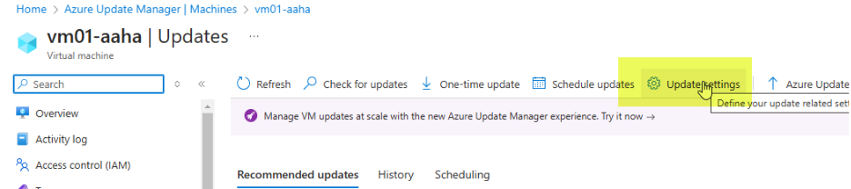
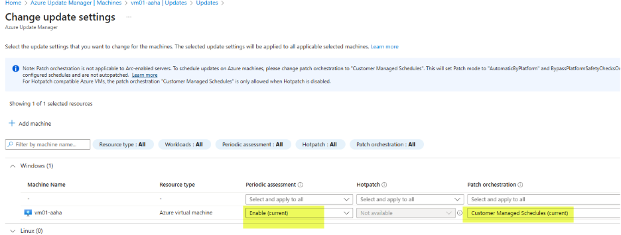
- Go to Update Manager>Resources>Machines>Maintenance configurations
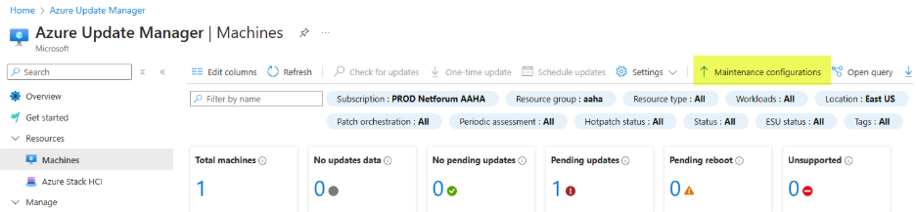
- Go to PROD-Netforum-Patching
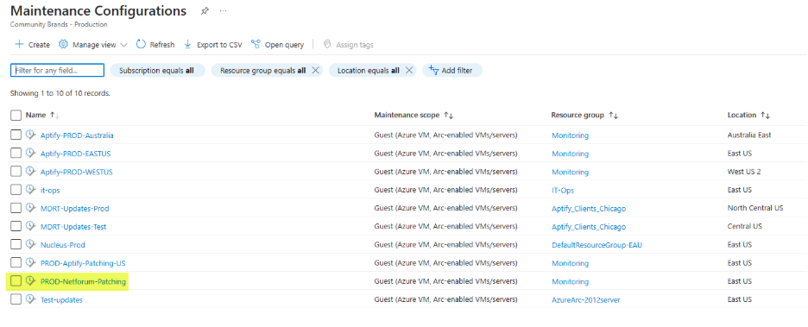
- Go to Resources and click Add
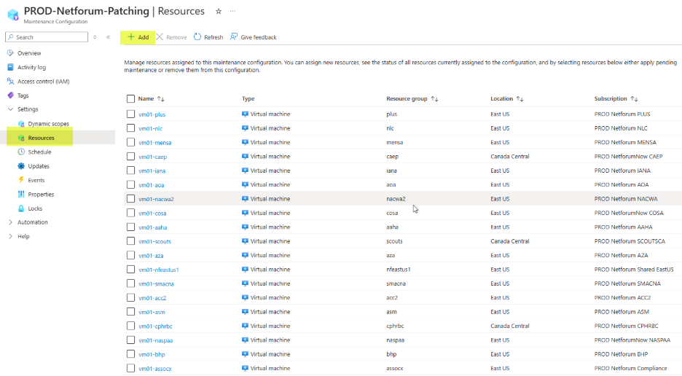
- Search for VM, select it and click Save
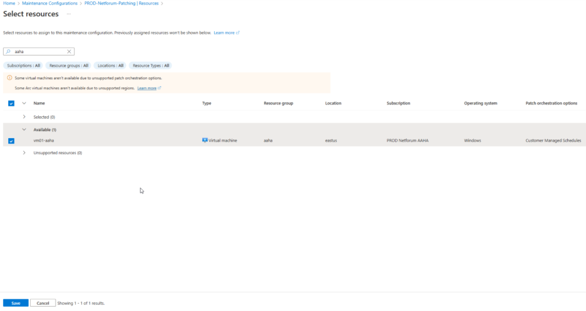

- Configure malware scanning on storage accounts
- Go to Microsoft Defender for Cloud>Environment Settings and click on subscription

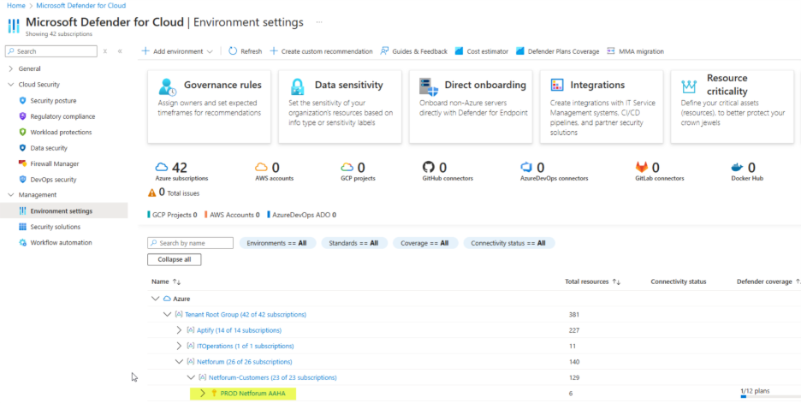
- Ensure storage status is On, and click on Settings link:
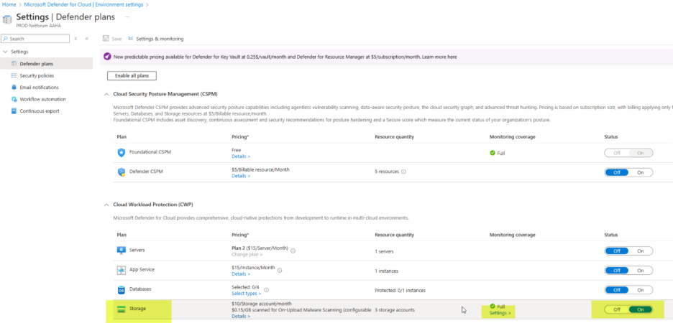
- If ‘Limit of GB scanned’ is not set to 35 GB, click Edit settings to set it:
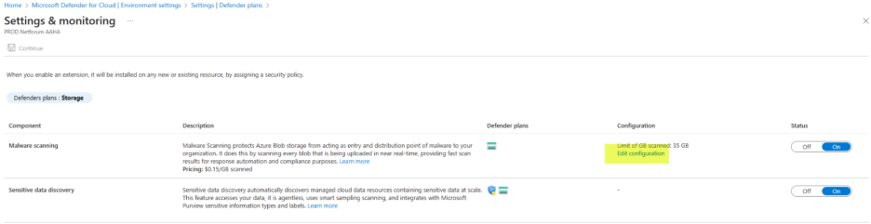
3. Create log analytics workspace. Example:
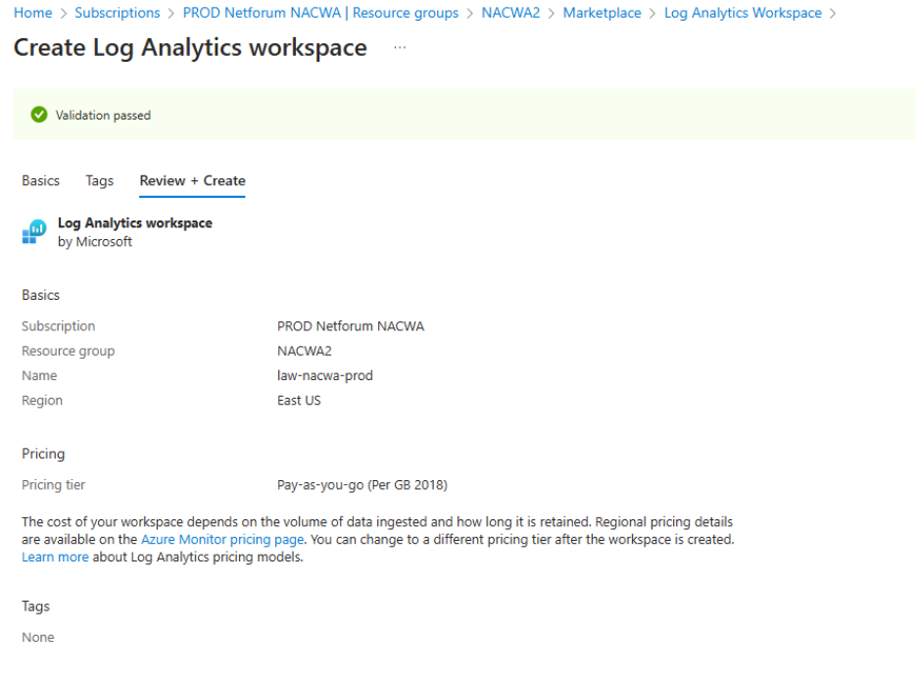

4. Set daily cap on log analytics workspace
- Go to Log Analytics workspaces and select workspace for subscription

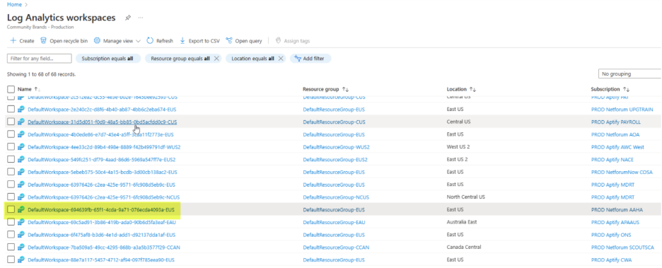
- Click on Usage and estimated costs
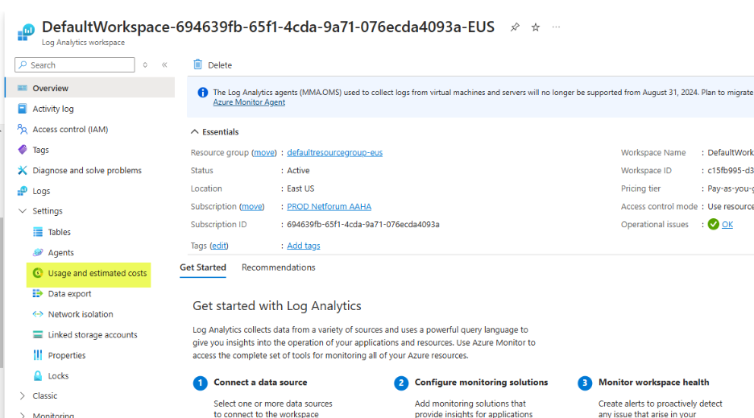
- Click on Daily cap
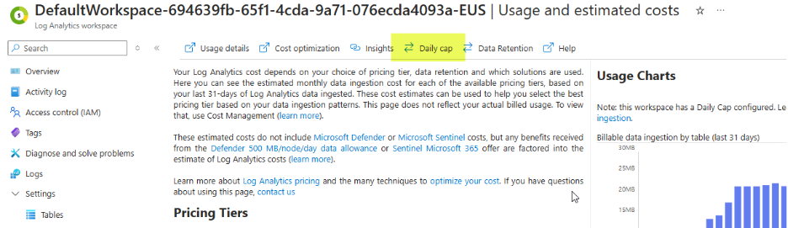
- Turn on and set daily volume cap to .25 GB/day
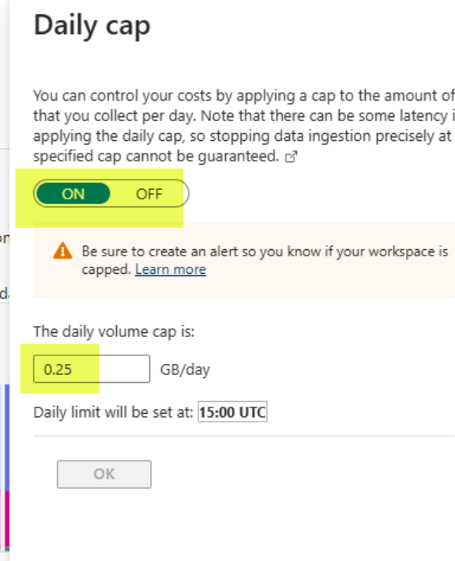

4. Configure resource group security alerts
- Go to Microsoft Defender for Cloud>Management>Workflow automation and click ‘Add workflow automation’

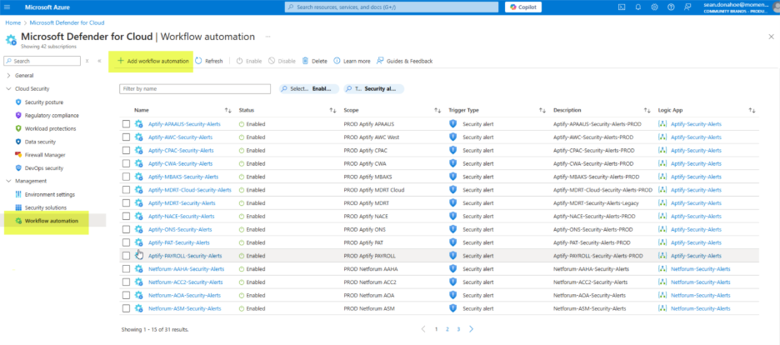
- Name = Netforum-<customer acronym>-Security-Alerts
- Subscription = subscription used for new deployment
- Resource Group = main resource group, ‘SMACNA’ for example
- Defender for Cloud data type = Security alert
- Alert severities = All severities selected
- Actions
- Select PROD IT Operations subscription
- Logic app name = Netforum Security Alerts
